DLP Plan Example

Fabrikam has the following environments and zero DLP policies today

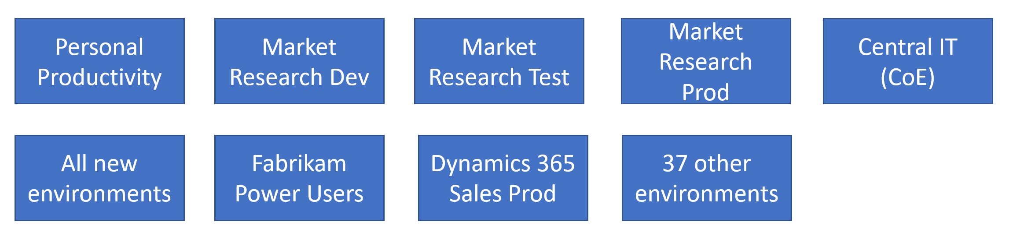

In the following document the DLP policies and their environments included/excluded. You may find it helpful to draw them on a whiteboard, or scratch piece of paper, Visio or PowerPoint.

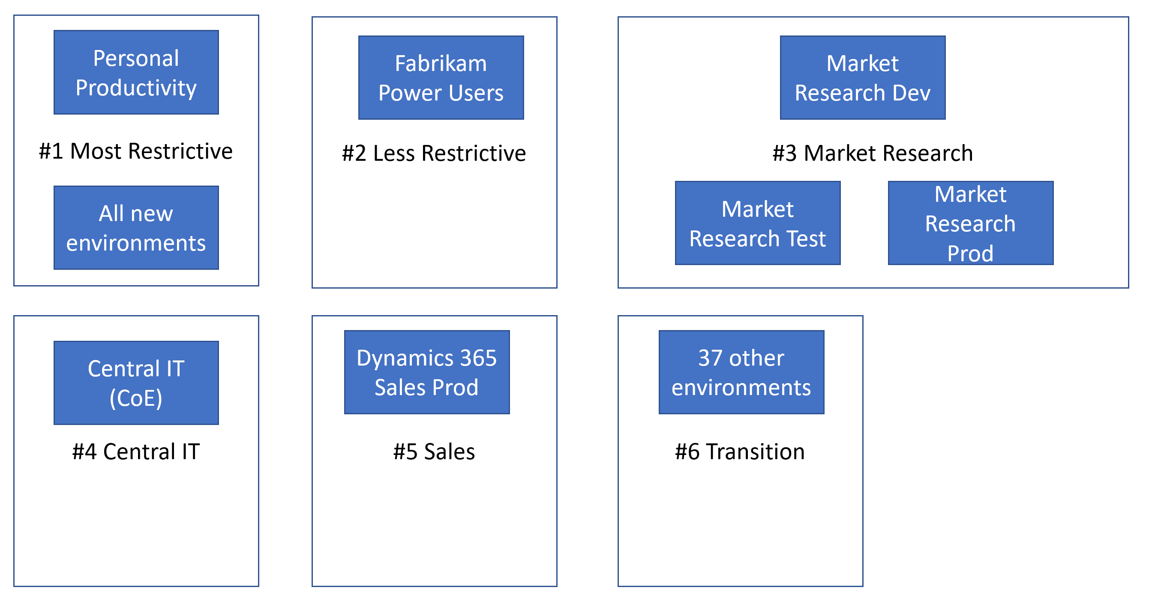

# DLP #1 – Most Restrictive

## Includes Environments

* All environments not excluded

## Excludes Environments

* All covered by DLP #2-6

# DLP #2 – Less Restrictive

## Includes Environments

* Fabrikam Power Users

# DLP #3 – Market Research

## Includes Environments

* Market Research Dev, Test, Prod

# DLP #4 – Central IT

## Includes Environments

* Central IT

# DLP #5 - Sales

## Includes Environments

* Dynamics 365 Sales Prod

# DLP #6 – Transition

Note: This is a temporary DLP policy to handle transitioning the 37 miscellaneous environments to a more managed state without impacting their day-to-day use during transition. Once all apps and automations have been moved out of those environments or specific exception policies created, the environment would be removed from this transition DLP

## Includes Environments

* 37 other environments